Mission: Partnering with staff, students, and their families to create a safe, healthy, and inclusive learning environment that provides an enjoyable and positive experience for the entire school community.
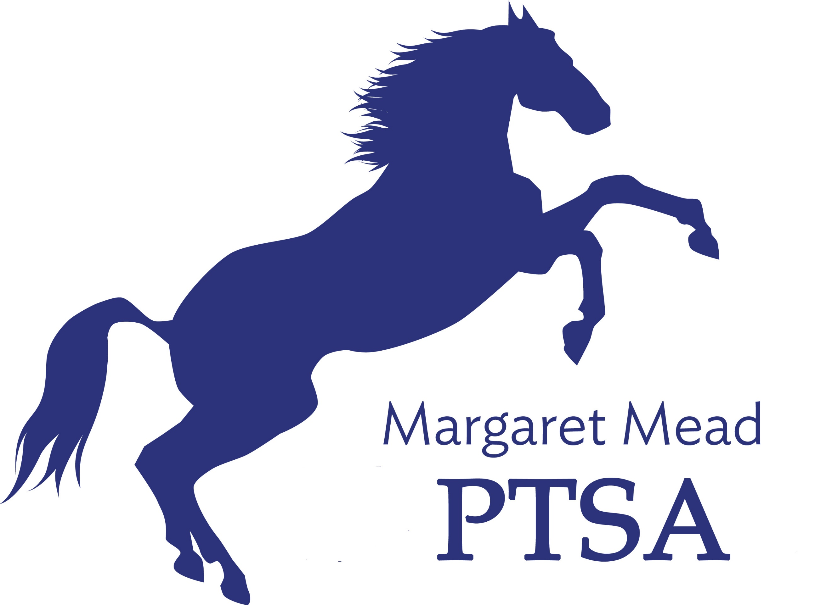
Margaret Mead Elementary PTSA
1725 216th AVE NE, Sammamish, WA 98074
PTSA Unit 2.8.38
www.meadptsa.org
Goal: Support the mission statement using
effective communication, connecting community, financial support & fiscal responsibility.
Board of Directors Meeting
MINUTES
November 19, 2020

Present: Leta Hamilton, Abi Nubla-King, Antoinette Haynes, Sharon Mason, Sharon Wu, Sarah Jensen, Ryika Hooshangi, Molly Hylen, Sandy Klein, Suzy Khendry, Liz Moore, Trista Lofti, Ashley Arrington, Sue Gabica, Ashwini Godbole, Cassy Patterson, Charles Jamieson, Daniela Toleda, Niko Olsen
- Call to Order – 7:00pm
- Approval of the Minutes – Approved & entered into record
- Executive Board Reports
President: Ryika Hooshangi
- Word on the street – teachers are working overtime trying to engage students. Parents are encouraged to tell their kids to keep their cameras on during online instruction. Kids are finding ways to work around the technology to not turn in assignments.
- Amazon Smile – 44 people enrolled. Just received $50 check. Sign up through website. Anyone can sign up to Amazon Smile & donate to Mead, grandparents & other relatives included. A good way to bring in passive funds. Please add a note about Amazon Smile in the next Mustang Report. Abi Nubla-King is going to write something up.
- Yearbook – No photographers are coming onto campus of elementary schools in LWSD. We are currently in a 2 year contract with the photographer who did last year’s photos. Ryika is in discussion with the photographer with whom we have a contract about postponing the contract to next year. Previous years yearbooks have simply been individual photos. We are considering doing something different for this year.
    - Suggestions: Set up a Drive By photo shoot at ESP
    - MOTION: Sharon Mason motioned to forego the usual yearbook experience due to Force Majeur of Covid 19. Instead, have parents submit pictures, which Ali Furwrtangler will organize for each class. Seconded Molly Hylen. MOTION PASSED
- Community building events
  - New PTSA “How to…” series
    - Mr. Jamieson starting this series on November 20. Series includes…How to make playdough. How to make donuts. How to make waffles. How to make a camp fire. How to make ice cream. How to make pie. How to make pancakes. Thanks to Abi for setting up a Mead private YouTube channel. Parents can subscribe to the Mead YouTube channel. Abi is looking for a volunteer who knows how to do an intro video & can splice it into each “How To” video. Mr. Jamieson is going to do this for the PTSA.
  - Other community engagement PTSA sponsored activities currently being organized:
    - Glass House Dance Studio is going to do a virtual dance class for Mead.
    - A Zumba Class in in the works.
    - Tai Dwon Do is on the list.
    - Talent Show – Ryika talked to Back to Rock school. They did a virtual talent show for Redmond Elementary School. K-2 one night. 3-5 on the next night. They offered a free class for all participants. One of their teachers MC’d for the virtual event.
    - There may be some fundraising possibilities from these classes.
Vice President: Abi Nubla-Kung
- PTSA Events:
  - Reflections, things have been judged. We have winners. 15 winners have gone on to council levels. 24 participants. Numbers down from last year. In comparison to other schools, we had more. Every participant will get a medal. We will arrange a socially distanced medal pick up. Sarah Jensen can take a picture with a computer. Sarah Jensen will send Abi the office hours when parents can come to collect medals.
  - Math Tournament, date is December 12. Only 26 people have signed up. This is a fundraiser. Extended deadline to November 30.
  - Spelling Bee is coming up on February 4. This also will be virtual. Spelling Bee chairs are organizing this to be a membership drive – PTSA members can sign up for free. Non Members will be charged a fee.
  - We are exploring ways to incentivize parents to become members. How can we make more things “members only?”
Secretary: Leta Hamilton
- Nominating Committee Volunteers – 97 non staff PTSA members. Ashwini asked one of her friends. Liz Moore, Leta Hamilton, Ashwini Godbole will be the nominating committee.
Treasurer: Molly Hylen
- Treasurer’s Report ending balance September $96,015.76 & October $100,577.01
- Old/Voided Check – we have some checks from previous years that have not cleared. Checks that have not cleared will need to be voided. Total is between $800-900. Molly Hylen motioned: I move that we void transactions (deposits and uncashed checks) from the 2017-2019 school years. All unclaimed dollars will be donated to our general fund. Sharon Mason seconded. Motion passed.
- Membership Donations – in the past we have handed out memberships around this time of year to staff members or scholarship requests.
- Pass the Hat update- $4,000. We are done asking for donations through pass the hat for this year.
- Taxes were filed. Molly is waiting to get them back. Insurance was renewed. Check is in the mail.

- Committee Reports
FACE: Liz Moore & Trista Lotfi
- Gingerbread House decorating competition will take place in December.
- Pumpkin carving decorating contest went well. Winners received coupons for Mead Spirit Wear.
- Redmond Art Works is offering prizes to us.
Legislative Advocacy: *Vacant position
Membership: Catherine Tian & Daniella Toledo
- Current Membership numbers – Abi did a data analysis to see what percentage of our school population is represented by the PTSA.
Volunteer Coordinator: Ashwini Godbole – nothing to report.
Fundraising: Sharon Mason & Ashley Arrington
- Restaurant fundraising update – MOD Pizza $455, Chipotle $200.
- Sara Cupp recommended FlipGive as a passive fundraising app. Scan receipts & raise money that way. Sharon is going to set it up so Mead families can use FlipGive.
- Read-A-Thon: students will count minutes. Read a thon will take place over a 2 week period. We’re trying to avoid breaks. February 22-March 5 are suggested dates. Coincide with Read Across America Week. Also, combine it with a Read Aloud virtual night for the Mead community. We have a budget of $5,000 for fund raising. We need a budget for prizes. Prizes would be books. Fundraising company would receive a portion of the money we raise.
Communications: Heather Gibbons & Sharon Wu
- PTSA online directory. Membership database is not updated. Membership drive by class is an idea. Sandy suggested a FORMS SURVEY sent out to families. All board members need to make sure their membership is up to date.
Sustainability: Suzy Khendry – nothing to report.
Emergency Prep: Antoinette Haynes & Cassy Patterson
- Pillowcase project – Quarterly ePrep meeting with other schools in the district. Pillow Case Project is a Red Cross sponsored project. They have an hour presentation on emergency preparedness. Presentation geared to grades 3-5. It’s offered for free by the Red Cross. Sandy will need to speak to staff. Could be an after school option? There’s no rush on this. Sharon Mason said that a local Scout Leader she knows could also do a Zoom presentation on safety preparedness,

- Principal/Staff Update Thank you to staff for all their hard work in difficult conditions! Sarah Jensen thanked the families for all the books purchased in the Scholastic Book Fair.

- Adjourn 8:57
NEXT BOARD MEETING IS A GENERAL MEMBERSHIP MEETING
Board Meeting—January 14, 2021 at 7:30pm
Upcoming Events
- Nov. 20: “How-To” series begins
- Dec. 16: Margaret Mead’s Birthday
- Dec. 17: Gingerbread House Decorating Competition*
- Jan. 14: General Membership Meeting (7:00pm)
- Jan 21: BINGO/Game Night
- Feb. 4: Board Meeting
- March 4: International Night

